*Optimising Users, Group, Role*

*Management*

Team Id:NM2025TMID16265

Team Members:4

Team Leader:DEEPALAKSHMI R.M

Team Member 1 :ESWARI S.

Team Member2:JAGADEESHWARI J Team Member 3 :ASHWINI V Problem Statement :

Objective:

Skills:



. Navigate to Users Module

1

Click on All in the left-hand navigation panel

In the search bar, type Users.

Under System Security, select Users.

. Create a New User

2

Click on the New button.

Fill in the required details such as:

User ID

First

Name

Last

Name

Email

Password (if applicable) Any other

required

fi

elds.

. Save User

3

After

fi

lling in the details, click Submit.

The new user is now created in the system.

a. In many organizations, managing user identities, roles, and group memberships is a manual, error-prone

process. Lack of automation and well-de

fi

ned access control leads to:

b. Unauthorized access or privilege escalation.

c. Administrative overhead in user provisioning and de-provisioning.

d.

Security risks due to inactive or orphaned accounts.

e. Poor compliance with organizational policies and standards.

Proposed Solution:

The project proposes an automated, role-based access control (RBAC) system integrated with work

fl

ow

management to:

f.

g. Manage users, groups, and roles efficiently.

h.

i.

j.

Provide secure, policy-driven access to resources.

Automate approval work

fl

ows for role assignments and access requests.

Improve auditing, monitoring, and compliance reporting.

USERS

:

Create Users:

*Steps to Create Users in ServiceNow*

1

. Open ServiceNow

Log in with your credentials.

To design and implement a system that simpli

fi

es user, group, and role management by integrating access

control policies and work

fl

ow automation, ensuring secure, efficient, and scalable management of organizational

resources

Optimizing User, Group, and Role Management

with Access Control and Workflows

Objective:

Problem

Statement:

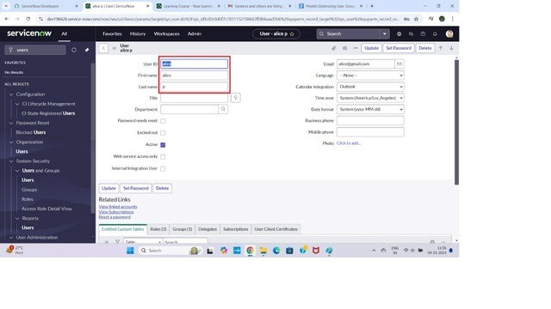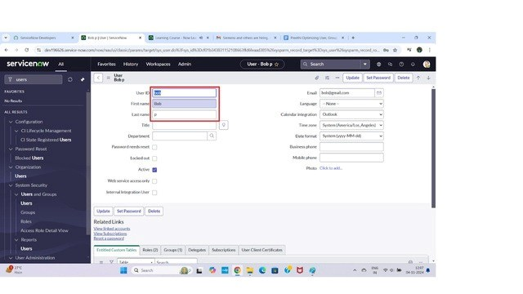

*Steps to Create Another User:*

1

. Add Another User

Repeat steps 2–3 to open the Users form again.

Enter the details for the second user (different User ID and email).

2

. Save User

Once the details are

fi

lled in, click Submit.

The second user is successfully created.

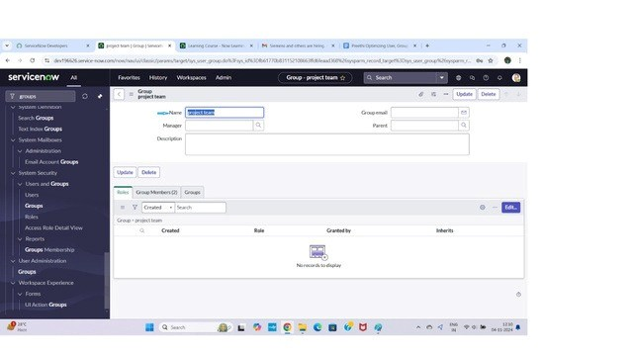

ROLES:

Create Roles in ServiceNow:

. Open ServiceNow

1

Log in to your ServiceNow instance with your credentials

.

GROUPS:

Create Groups in ServiceNow:

1

. Open

ServiceNow

Log in to your ServiceNow instance with the required admin or security role.

2

. Navigate to Groups

In the left navigation pane, click on All.

Use the search bar and type Groups.

Under System Security, sect Groups.

3

. Create a New Group

Click on the New button at the top of the Groups list.

4

. Fill in Group Details

Enter the required information for the group, such as:

Name – The unique name of the group (e.g., HR Support Team).

Description – A short explanation of the group’s purpose.

Manager – Assign a user as the manager of the group.

Email – Provide a group email if available.

Roles – Add roles if the group should have speci

fi

c access rights.

5

. Submit the Group

After

fi

lling in all details, click on Submit to create the group.

6

. Verify Creation

The new group will now appear in the Groups list.

You can open the group record to add members, assign roles, or update details later.

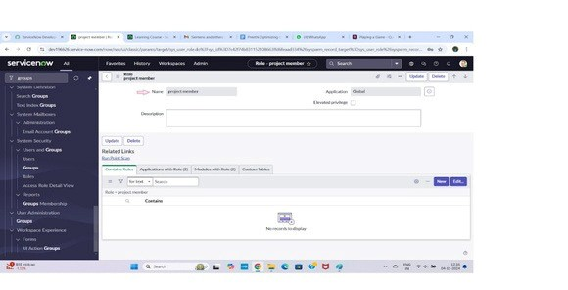

)

. Create Another Role (Example: Team Member

6

Repeat steps 3 to 5.

In the Name

fi

eld, enter: Team Member.

Provide a short description (e.g., Basic access for project team members).

Assign any required inherited roles if needed.

Click Submit.

. Verify and Manage Roles

7

After submission, both roles will appear in the Roles list.

2

. Navigate to Roles

In the left navigation pane, click on All.

In the search bar, type Roles.

From the results, under System Security, select Roles

.

3

. Create a New Role

On the Roles list page, click New (top-right corner).

. Fill in Role Details

4

In the New Role form, enter the required information:

Name – Provide a unique name for the role (e.g., Admin Role, Change Approver).

Description – Brie

fl

y explain the purpose of the role.

Elevated Privileges – (Optional) enable if the role needs higher permissions.

Contains Roles – (Optional) you can add existing roles that this new role will inherit.

5

. Save the Role

After

fi

lling in details, click Submit.

The new role is now created and appears in the roles list

.



You can reopen them later to:

Modify role details.

Add or remove inherited roles.

Assign the role to speci

fi

c users or groups.

TABLES:

Create table in ServiceNow:

1

. Open ServiceNow

Log in to your ServiceNow instance with the required credentials.

2

. Navigate to Tables

In the left navigation pane, click All.

In the search bar, type Tables.

Under System De

fi

nition, click on Tables.

3

. Create a New Table

On the Tables list page, click New (top-right corner).

4

. Fill in Table Details

In the New Table form, enter the required information:

Label: Enter Project Table.

5

. De

fi

ne Menu Name

Under New Menu Name, type Project Table.

This ensures your new table appears as a menu item in the application navigator.

6

. Add Table Columns

Scroll down to the Columns section.

Click New to add

fi

elds/columns.

Example columns for Project Table:

Project Name – String (Stores the project title)

Project ID – Integer or Auto Number (Unique identi

fi

er for each project)

Start Date – Date/Time (When the project begins)

End Date – Date/Time (When the project ends)

Status – Choice (Values like Planned, In Progress, Completed)

Assigned To – Reference (References the User table to assign a project owner)

Description – String or Journal Input (Project details/notes)

7

. Submit the Table

Once all details and columns are added, click Submit.

8

. Verify the New Table

After submission, go to Application Navigator.

Search for Project Table.

You should see the new menu and module created.

Open it to add, view, or edit project records.

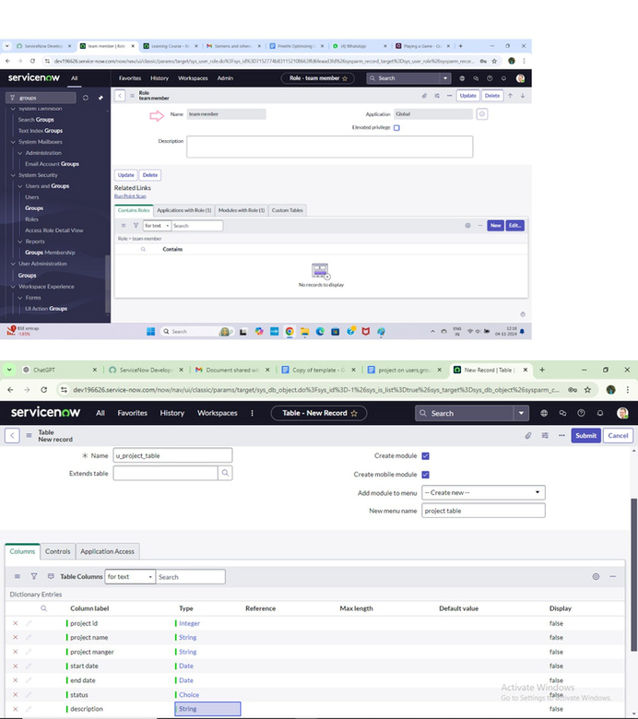

*Create one more table:*

9.Create another table as: task table 2 and fill with following details.

10. Click on submit.

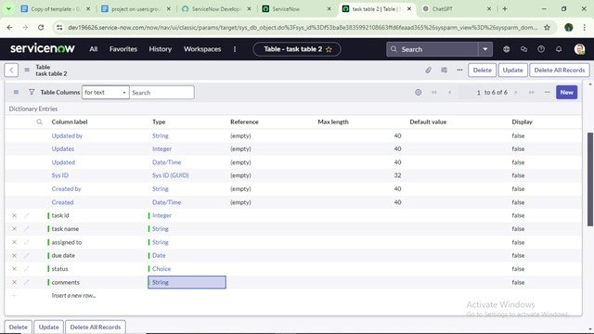

ASSIGN USER TO GROUPS:

Assign users to project team group:

1

. Open ServiceNow

Log in to your ServiceNow instance with valid credentials.

2

. Navigate to Groups

In the left-hand navigation pane, click

All

.

In the search bar, type

Groups

.

Under

System Security

, select

Groups

.

3

. Open the Project Team Group

From the list of available groups, search for

Project Team Group

.

Click on the group name to open its details page.

4

. Manage Group Members

On the group record form, scroll down to the

Group Members

related list.

Click on the

Edit

button (top-right of the Group Members section).

5

. Add Users to the Group

A pop-up window will appear showing

Available Users

on the left and

Selected Users

on the right.

From the

Available Users

list, search for and select:

Alice P

Bob P

Use the

→ (Add)

button to move them to the

Selected Users

list.

6

. Save the Changes

After selecting the users, click

Save

(or

Done

, depending on your instance version).

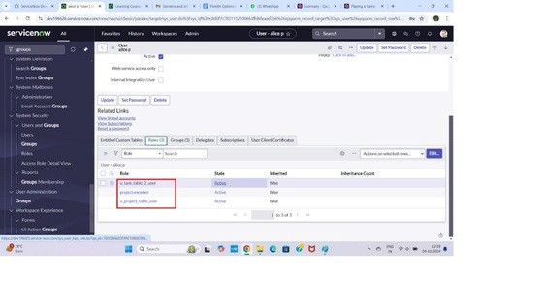

ASSIGN ROLES TO USERS:

Assign users to project team group:

1

. Open ServiceNow

Log in to your ServiceNow instance using your credentials.

2

. Navigate to Groups

In the left-hand Application Navigator, click All.

In the search bar, type Groups.

Under System Security, select Groups.

3

. Open the Project Team Group

From the list of groups, locate Project Team Group.

Click on it to open the group record.

4

. Manage Group Members

Scroll down to the Group Members related list on the group form.

Click Edit (top-right of the Group Members section).

5

. Add Users to the Group

A window will appear with two panels:

7

. Verify Assignment

Back on the

Project Team Group

record, under

Group Members

, con

fi

rm that

Alice P

and

Bob P

are listed.

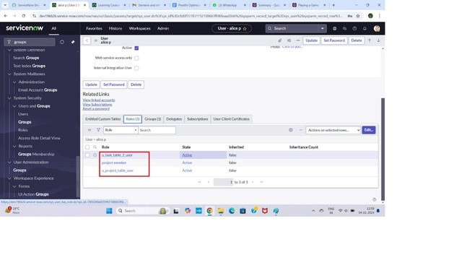

Assign roles to bob user:

. Open ServiceNow

1

Log in to your ServiceNow instance with admin access.

2

. Navigate to Users

In the

Application Navigator

, click

All

.

Type

Users

in the search box.

Under

System Security

, select

Users

.

3

. Select the User (Bob P

)

Available Users (left)

Selected Users (right)

From Available Users, search for and select:

Alice P

Bob P

Move them to the Selected Users panel using the → (Add) button.

. Save the Changes

6

Once Alice P and Bob P are added to the Selected Users list, click Save (or Done depending on your

version).

. Verify Membership

7

Return to the Project Team Group record.

Under Group Members, con

fi

rm that Alice P and Bob P are now listed as members of the group.

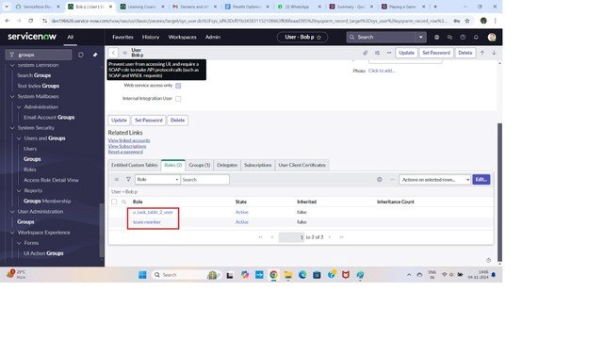

APPLICATION ACCESS:

Assign table access to application :

From the user list, search for

Bob P

.

Click on

Bob P

to open the user record.

4

. Assign a Role to the User

Scroll down to the

Roles

related list on the user form.

Click

Edit

.

In the

Available Roles

list, search for:

Team member

(or your created "Team Member" role).

Any additional table-speci

fi

c role if required (e.g., access to

*Project Table*

).

Move them to the

Selected Roles

panel.

5

. Save the Changes

Click

Save

(or

Done

, depending on your version).

Now Bob P has the assigned

Team Member

role and table permissions.

6

. Impersonate the User

In the top-right corner of the screen, click the

Pro

fi

le icon

.

Select

Impersonate User

.

Search for and choose

Bob P

.

ServiceNow will switch your session to Bob P’s view.

7

. Verify Access

In the

Application Navigator

, search for

Project Table

(or Task Table if you named it that way).

Con

fi

rm that Bob P can see and access the table and its records.



1

. Table Creation and Automatic Application Generation

When you create a new table in ServiceNow (e.g., Project Table), ServiceNow automatically generates:

A corresponding Application in the Application Navigator.

A Module that links to the table.

2

. Locate the Project Table Application

Open ServiceNow.

In the Application Navigator, search for Project Table.

You will see the newly created Project Table application.

3

. Edit the Module for Project Table

Right-click the Project Table module (under the Project Table application).

Select Edit Module.

In the module form, scroll to the Roles

fi

eld.

Assign the role Project Member to this module.

This ensures only users with the Project Member role can access the Project Table.

Click Save or Update.

4

. Edit the Task Table 2 Application

In the Application Navigator, search for Task Table 2.

Right-click on the Task Table 2 application and choose Edit Application.

In the application form, go to the Roles section.

Assign both:

Project Member role

Team Member role

(

This allows users with either role to access Task Table

2.)

Click Save or Update.

5

. Verify Access

Impersonate a user with the Project Member role → con

fi

rm they can access Project Table.

Impersonate a user with the Team Member role → con

fi

rm they can access Task Table 2.

Users without these roles should not see these applications in the navigator.

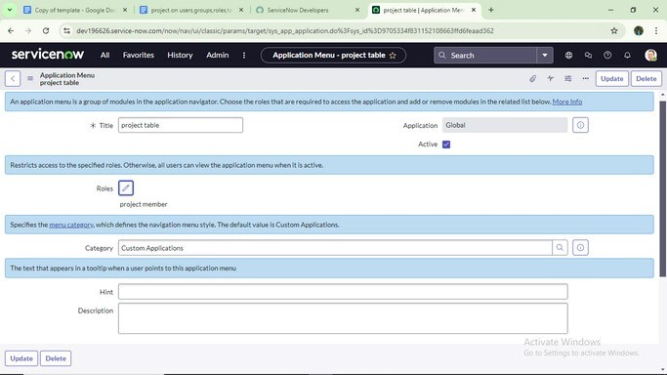

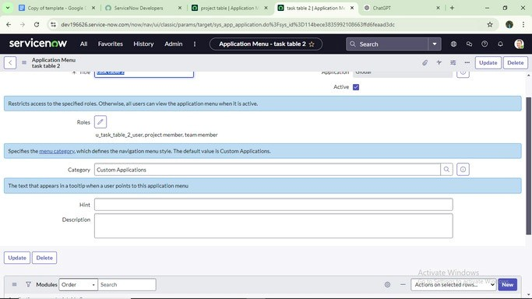

ACCESS CONTROL LIST: Create ACL:

1. Open ServiceNow

Log in to your ServiceNow instance with administrator credentials.

1. Navigate to Access Controls

In the Application Navigator, click All.

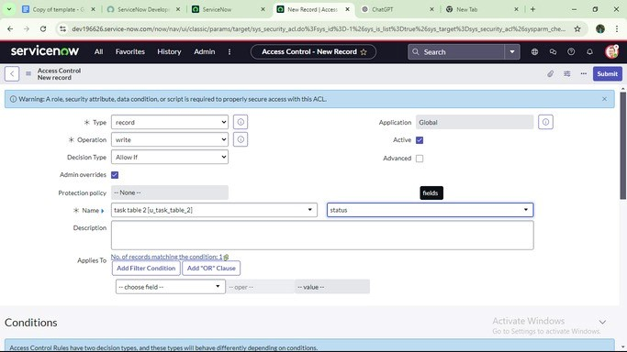

In the search bar, type

ACL

.

Under

System Security

, select

Access Control (ACL)

.

3

. Elevate Role (if required

)

Some ACL operations require

security admin

privileges.

Click on the

Pro

fi

le icon

(top right corner).

Select

Elevate Roles

.

Check the box for

security admin

.

Click

OK

.

Now you have elevated privileges to create or modify ACLs.

4

. Create a New ACL

In the

Access Control (ACL)

list, click

New

.

5

. Fill in ACL Details

In the

New Access Control

form, provide the following details:

6

. Save the ACL

Click

Submit

to save the new ACL.

7

. Verify ACL Functionality

Impersonate a user with the assigned role → con

fi

rm they have access.

Impersonate a user without the role → con

fi

rm access is denied.

1

.

Open ServiceNow → Go to All > ACL under System Security.

2

.

Elevate Role → Select security admin.

3

.

New ACL → Choose Record, pick Task Table, and set operation (Read/Write/Create/Delete).

1. Requires Role → Add Team Member role.
2. Submit.
3. Repeat → Create 4 ACLs for Task Table: Read, Write, Create, Delete (all require Team Member role).
4. Verify → Impersonate a user with/without the role to test access.

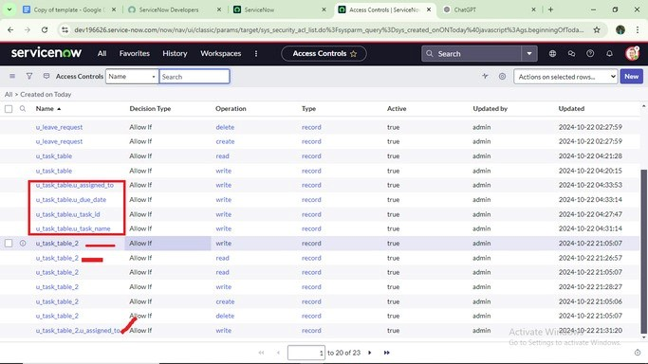

15. Click on profile on top right side

1.Click on impersonate user

2.Select bob user

3.Go to all and select task table 2 in the application menu bar

4. Comment and status fields are have the edit access

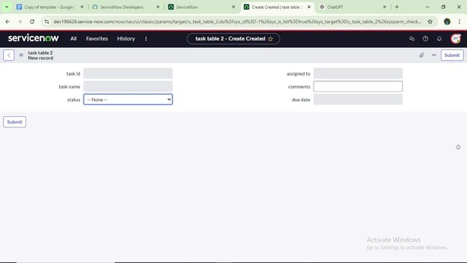

FLOW:

Create a

fl

ow to assign operations ticket to group:

1

. Open ServiceNow

Log in to your ServiceNow instance with valid credentials.

2

. Navigate to Flow Designer

In the Application Navigator, click All.

In the search bar, type Flow Designer.

Under Process Automation, select Flow Designer.

3

. Create a New Flow

Once Flow Designer opens, click New.

From the options, select Flow.

4

. De

fi

ne Flow Properties

In the Flow Properties window,

fi

ll in the details:

Flow Name → Enter Task Table.

Application → Set to Global.

(

Optional) Add a Description if needed.

Click Submit.

5

. Build the Flow

After saving, click Build Flow to open the Flow Designer editor.

Here you can add:

Trigger → De

fi

ne when the

fl

ow should run (e.g.,

*When a record is created in Task Table*

).

Actions → De

fi

ne what happens next (e.g.,

*Send email, update record, create task*

).

6

. Save and Activate

Click Save and then Activate the

fl

ow so it’s ready for use.

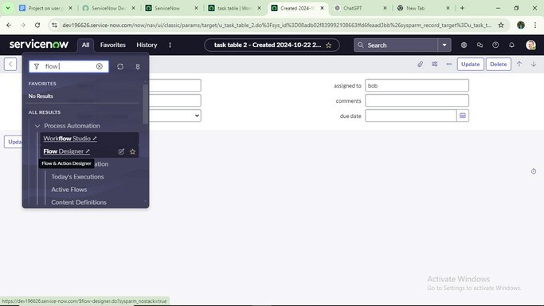

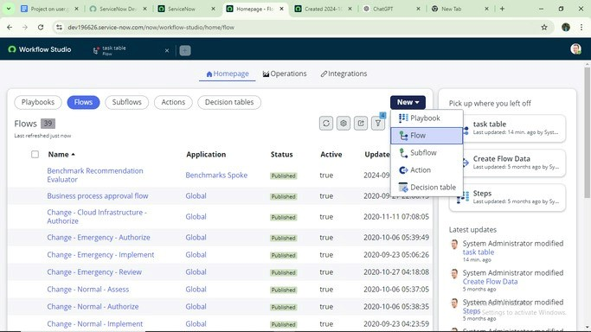

1. Open the Flow

In Flow Designer, open the flow you created earlier (Task Table).

1. Add a Trigger

Click on Add a trigger.

In the trigger options, search for Create Record.

Select Created Record → this will make the flow run whenever a new record is created.

1. 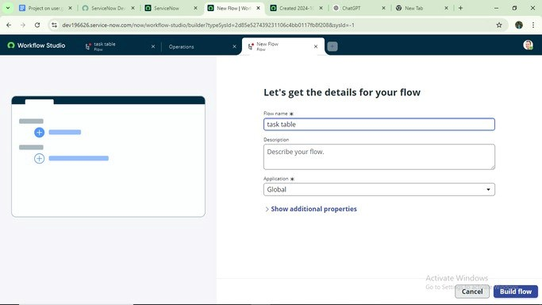Configure the Trigger

In the Table field, select Task Table.

Add the following conditions so the flow only runs when these criteria are met:

1. Field: Status → Operator: is → Value: In Progress
2. Field: Comments → Operator: is → Value: Feedback
3. Field: Assigned To → Operator: is → Value: Bob
4. Save the Trigger

After entering the conditions, click Done.

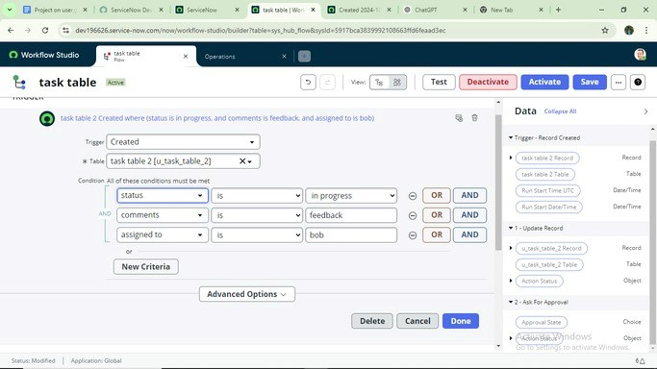

1

. Open Your Flow

In Flow Designer, open the Task Table

fl

ow you created.

Ensure you’ve already added the Trigger (Create Record with conditions).

2

. Add an Action

1

.

After the trigger, click Add an Action.

2

.

In the action options, search for Update Record(s).

3

.

Select Update Record(s).

3

. Con

fi

gure the Action

1

.

In the Record

fi

eld:

Drag the Record object from the Data Panel (right side, under Data Pills) into the Record

fi

eld.

This ensures the action updates the same record that triggered the

fl

ow.

The Table will auto-populate as Task Table.

2

.

Under Fields to Update, set:

Field: Status → Value: Completed.

4

. Save the Action

Click Done once the con

fi

guration is complete.

5

. Finalize and Activate Flow

1

.

Click Save at the top of Flow Designer.

2

.

Then click Activate so the

fl

ow starts running.

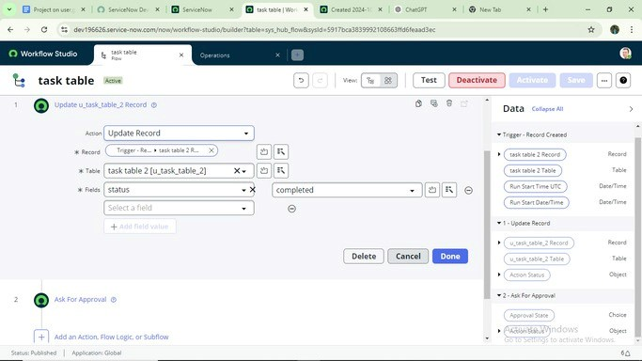

1

. Open the Flow

In Flow Designer, open your existing Task Table

fl

ow.

Ensure the Trigger and

fi

rst Action (Update Records) are already in place.

2

. Add a New Action

1

.

Under Actions, click Add an Action.

2

.

In the action search bar, type Ask for Approval.

3

.

Select Ask for Approval.

3

. Con

fi

gure the Approval Action

1

.

Record

fi

eld:

From the Data Panel on the right (Data Pills), drag the Record object into the Record

fi

eld.

The Table will automatically be set to Task Table.

2

.

Approval

fi

eld:

Set to Status → this is the

fi

eld that re

fl

ects the approval decision.

3

.

Approver(s):

Select or type Alice P as the approver.

(

You can also add multiple approvers if needed

).

4

. Save the Action

Click Done to add the approval step into your

fl

ow.

5

. Save and Activate Flow

Click Save (top-right of Flow Designer).

Then click Activate to enable the updated

fl

ow.

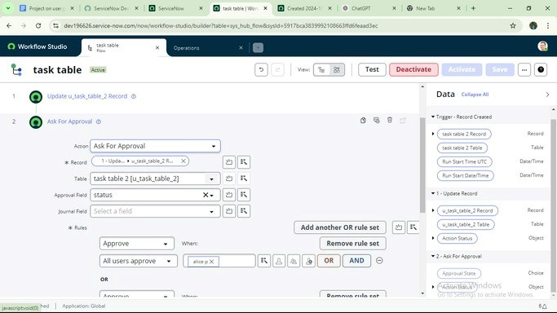9.Go to application navigator search for task table. 10.It status field is updated to completed

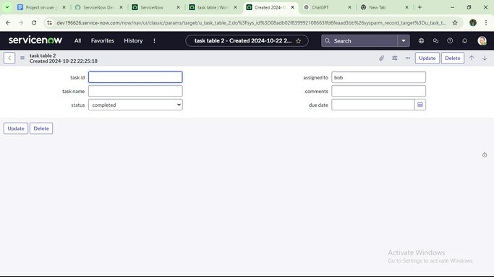

1. Open ServiceNow

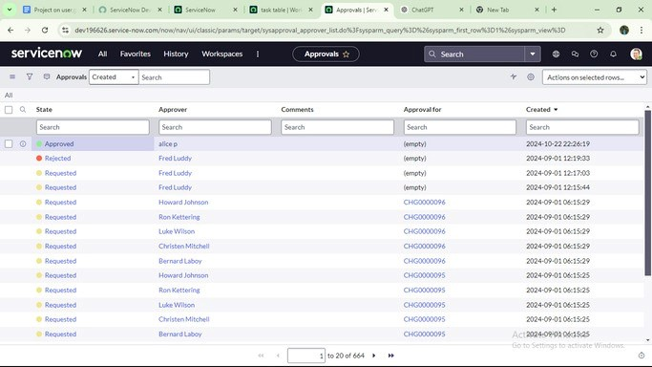

Log in to your ServiceNow instance.

Make sure you are logged in (or impersonating) as Alice P (the approver assigned in the Flow).

2

. Navigate to My Approvals

1

.

In the Application Navigator, search for My Approvals.

2

.

Under the Service Desk section, click My Approvals.

3

. Review Approval Request

1

.

In the My Approvals list, locate the approval request that was generated by the Task Table

fl

ow.

2

.

Right-click on the request record.

4

. Take Action (Approve or Reject

)

1

.

From the right-click options, select Approve.

This will update the request as approved.

Since the approval

fi

eld is mapped to Status, the record will re

fl

ect this change.

2

.

(

Optional) If the approver wanted to reject instead, they could choose Reject.

5

. Verify

Once approved, go back to the Task Table record.

Con

fi

rm that the Status has been updated according to the approval action.